RESPONDUS
The Install link: https://download.respondus.com/lockdown/download.php?id=282146801
Open Course Blocks/Add a block/Respondus

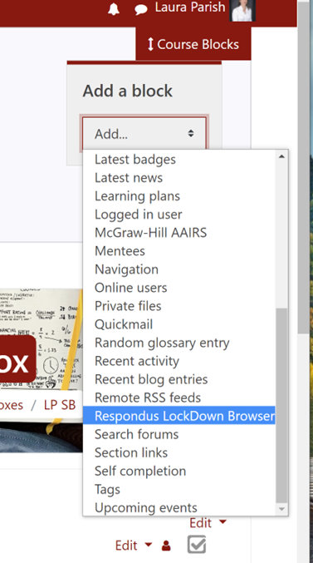
Click on the Dashboard

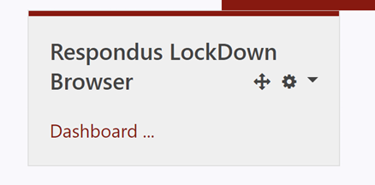
Find the quiz or exam you want to add Respondus to, click on settings
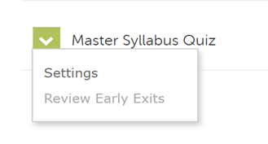
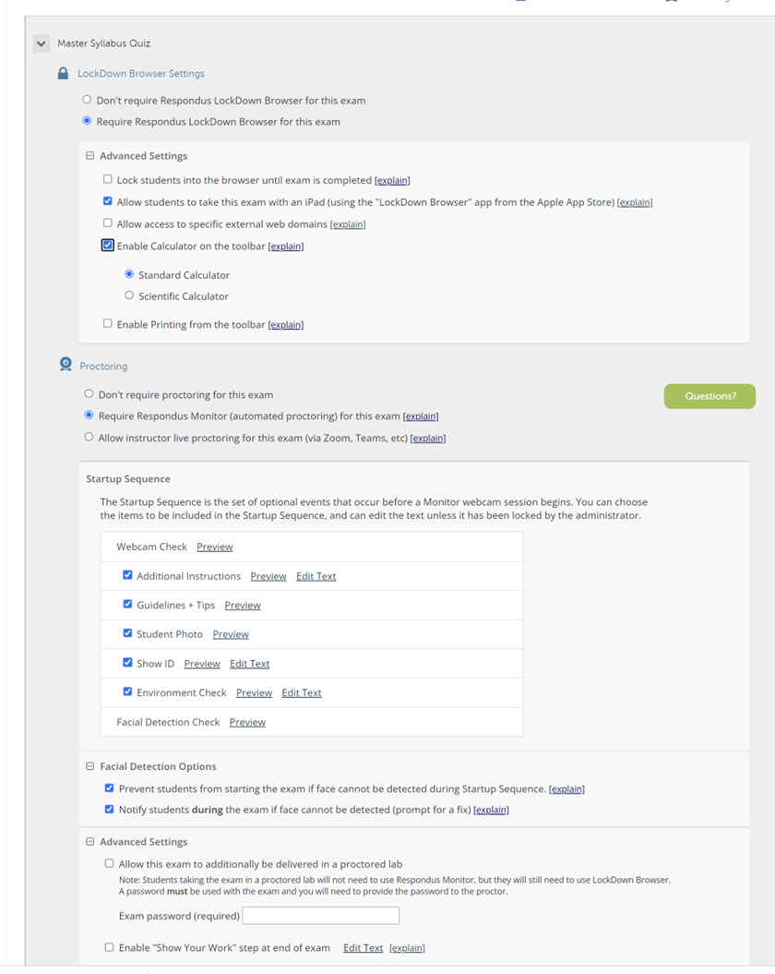

Choose your settings. You must choose Require Respondus and if you want it monitored, you must choose Require Respondus Monitor. The other settings are options that you can choose from such as a calculator, show ID and Facial Detection.

Save and Close
If it is set up correctly, you’ll see Required and Respondus Monitor in GREEN
Video on Respondus: https://web.respondus.com/respondus-monitor-overview-video/
Instructor Quick Start Guide: https://web.respondus.com/wp-content/uploads/2020/06/RLDB-QSG_Moodle-Instructor.pdf
The student video to share in your course for students: https://web.respondus.com/lockdownbrowser-student-video/
Student Quick Start Guide to share: https://web.respondus.com/wp-content/uploads/2019/08/RLDB-Quick-Start-Guide-Moodle-Student.pdf

